Bone Density Exam Testing at the Family Health Care Center of Royal Oak
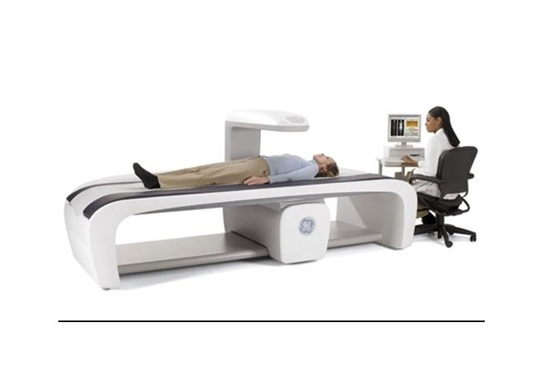

A bone density test is the only test that can diagnose osteoporosis before a broken bone occurs. This test helps to estimate the density of your bones
and your chance of breaking a bone. NOF recommends a bone density test of the hip and spine by a central DXA machine to diagnose osteoporosis. DXA stands for dual energy x-ray absorptiometry.
You can find out whether you have osteoporosis or if you should be concerned about your bones by getting a bone density test. Some people also call it a bone mass measurement test. This test uses a machine to
measure your bone density. It estimates the amount of bone in your hip, spine and sometimes other bones. Your test result will help your healthcare
provider make recommendations to help you protect your bones.
Are you a postmenopausal woman or man age 50 and older? Have you recently broken a bone? If you answered “yes” to both questions, you should talk to your doctor or other healthcare provider about getting a bone density test if you’ve never had one.

What a Bone Density Test Can Do

A bone density test tells you if you have normal bone density, low bone density (osteopenia) or osteoporosis. It is the only test that can diagnose osteoporosis. The lower your bone density, the greater your risk of breaking a bone. A bone density test can help you and your healthcare provider:

- learn if you have weak bones or osteoporosis before you break a bone

- predict your chance of breaking a bone in the future

- see if your bone density is improving, getting worse or staying the same

- Find out how well an osteoporosis medicine is working

- let you know if you have osteoporosis after you break a bone

Who Should Have a Bone DensityTest?

NOF (National Osteoporosis Foundation) recommends that you have a bone density test if:

- you are a woman age 65 or older

- you are a man age 70 or older

- you break a bone after age 50

- you are a woman of menopausal age with risk factors

- you are a postmenopausal woman under age 65 with risk factors

- you are a man age 50-69 with risk factors

A bone density test may also be necessary if you have any of the following:

- an X-ray of your spine showing a break or bone loss in your spine

- back pain with a possible break in your spine

- height loss of ½ inch or more within one year

- total height loss of 1½ inches from your original height

Ask your health care provider if you are a candidate for our state of the art GE Bone Density testing.

